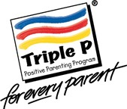
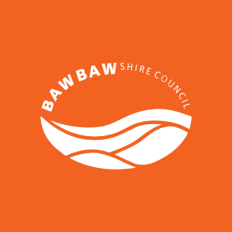
Triple P - Positive Parenting Program

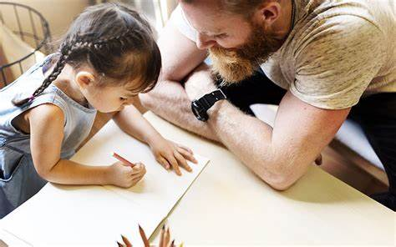
Do you have children aged 2-5 years?

Come along to a free, relaxed and informal three-part series of seminars that provide you with practical advice and tips on becoming a more positive, confident parent. You can choose to come to one, or all!

These seminars will cover a variety of parenting topics, understanding children’s behaviour and provide advice about raising confident, competent and resilient children.

Thorpdale – Thorpdale Primary School, Robinson Street, Thorpdale
Date | Seminar topic
Thursday 12 March  9.15am – 10.45am | The power of positive parenting  Creating loving, supporting and predictable family  environments.
Friday 20 March  9.15am – 10.45am | Raising confident, competent children  Building secure and positive relationships with your child or children.
Thursday 26 March  9.15am – 10.45am | Raising resilient children  Helping your child or children cope with their feelings.

Want to know more? Give Family and Children’s Services a call on 5624 2540.
>> bawbawshire.vic.gov.au
bawbawshirecouncil
@bawbawshire
T 03 5624 2540

