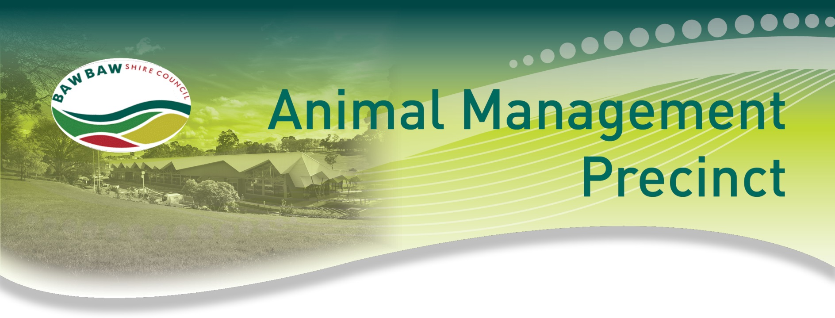

Fact Sheet

Historical Background

- The existing Animal Management Pound (Galloway Street Warragul) was built in 1991. In 2014, an audit conducted by the Bureau of Animal Welfare determined Council’s pound facility as non-compliant with the Code of Practice for the Operation of Animal Pounds and Shelters. Council immediately implemented temporary measures to ensure the facility is able to operate at minimum compliancy.

- Since its construction some 26 years ago, our Shire has experienced significant growth. That growth has placed greater operational strain on our pound facility. Over time, this strain has taken its toll on the facility, and led to increased costs to maintain the facility due to its age, compliance requirements and lack of space.

- Council’s current pound is not fit for purpose and unable to adequately accommodate the growing requirements of our Shire. In particular, the current pound has very limited capacity to accommodate livestock and on occasions Council has had to lease land at an additional cost. Council in partnership with farmers and the livestock exchange has been able to keep these costs to a minimum, however we recognise this may not be sustainable going forward.

- To keep our facility compliant until the pound renewal can be completed, Council has made a number of improvements to the existing pound at Galloway Street, Warragul. Works included:
  - Resealing some of the pens.
  - Laying additional floor surfaces to ensure that the surfaces were impervious, easy to clean, and prevented any biosecurity risks and cross contamination.
  - Plumbing repairs, and
  - Replacement of dog water drinking bowls.

These works were all performed for a minor cost. (It is worth noting that in the event of any damages to the pound caused by an impounded animal, the animal’s owner is responsible for repair costs.)

- The current pound (Galloway Street, Warragul) has the capacity to hold up to eight (8) dogs and nine (9) cats. There are no isolation facilities and the pound is often at or beyond capacity.

- Council understands that many of the impounded domestic animals belong to members of our community. Our aim is to ensure that your pet’s experience whilst temporarily impounded is as safe, warm and comfortable as possible. We know the current pound is not the most attractive facility, and that’s why we are committed to building a new pound; to ensure we provide the best outcome for all animals temporarily in our care.
- In the 2012-2016 period, Council identified that a new pound was a key project. Council set aside budget and commenced a thorough community engagement process to explore suitable locations for a new pound to be constructed. Three options were initially identified as potential sites. However, Council also sought additional recommendations for potential sites from members of the community.

Why Utopia?

- The Utopia Pet Lodge site was brought to Council’s attention as a possible option during the public consultation period.

- Utopia Pet Lodge is a five acre property in Longwarry North. It offers a footprint that would cater for a new pound facility (separately located to the Pet Lodge) as well as holding yards for livestock. This would obviate the need to lease additional land (as is currently the case), which would in turn reduce operating costs. The Utopia precinct presented a viable solution to meet future growth, even offering the potential to provide pound management services to neighbouring Councils.

- The surrounding community is already established, which would keep impact to amenity to a minimum.

- Utopia Pet Lodge was deemed the most viable option as the site of the new pound.

- Initially, the new pound was envisaged to be a separate facility with independent access, neighbouring the Utopia Pet Lodge.Further, it was planned that by assuming the operation of the Utopia Pet Lodge, Council would have an additional revenue stream for years to come which is aimed at offsetting sunk cost incurred by running the pound year-on-year, reducing the burden on rate payers.

- With this plan in mind, Council sought an independent due diligence report prior to the purchase of Utopia Pet Lodge. A condition of this report was that it would remain commercial in confidence unless consent was granted otherwise by the independent consultant who undertook the due diligence. Such consent has not been granted. As such, Council is precluded from releasing the report.

- Further, Council conducted a special meeting on the 10 August 2016 to assess the findings of the due diligence report. Council determined that the assessment of the report’s findings would also remain commercial in confidence. However, under authorisation of the Chief Executive Officer council is able to publicly release details that are of a non-commercial nature. The following details are publically available and released:

  - A purchase price of $1.2 million was determined
  - The property valuation (as per the independent report) was $970,000
  - The business valuation (as per the independent report) was $115,000
  - The balance was determined as part of negotiation

- On the basis of the independent due diligence and Council’s assessment of its findings, Council purchased Utopia Pet Lodge in September 2016 for $1.2 million, with the intent to co locate the new pound on this site; and this new pound would meet the Code of Practice for the Operation of Animal Pounds and Shelters, and more suitably accommodate the needs of our community.

Learnings

- In August 2016, Council had intended to utilise some of the existing structures already located at the Utopia site (but which were not attached to the Pet Lodge itself) to house the renewed pound facility. At the time, a Council assessment predicted that the cost to retrofit the existing structures would be in the vicinity of $150,000. However, following settlement of the site and further inspections, it was determined that the existing sheds were not structurally sound, and the costs to undertake works on these sheds would outweigh the costs of removing them from site and building from scratch.

- The efficiencies and costs of operating the Pet Lodge as a Council-run business could be optimised by co-location, and these optimised efficiencies could offset the costs of pound operation. Until the pound is constructed and operational, however, these efficiencies and offsets cannot be realised.
- Council accepts that the purchase of a commercial business was a new and different approach to the way Council has operated historically. However, facing new challenges such a rate capping and escalating costs associated with population growth, Council determined that proceeding with this business proposition offered an innovative solution that would ultimately provide a positive outcome for rate payers

Additional Information

- Council does not utilise any properties in Labertouche for the impounding of animals.

- In 2015/16, 419 domestic animals were collected and 292 reclaimed.

- In 2016/17, 392 domestic animals have been collected of 31 March 2017, with 215 reclaimed as of the same date.

- Baw Baw Shire Council purchased Utopia Pet Lodge in September 2016 with the intention of diversifying its revenue stream in a rate-capped environment and reducing the financial burden on its ratepayers.

- Under the Domestic Animals Act 1994, Council Officers are responsible for undertaking audits and registering all domestic animal businesses in line with the State Government Code of Practice.

Concerns have been raised by Domestic Animal Businesses regarding Council Officers independence in undertaking their statutory role, given the Baw Baw Shire Council’s recent decision to purchase and operate the Utopia Pet Lodge. Whilst Council remains confident that Officers execute their duties professionally, to remove any doubt that the annual audit is conducted with complete independence, Council has engaged a contractor to undertake this role for those domestic animal businesses that were considered to be in competition with the Utopia Pet Lodge.

The costs associated with the audit by an independent auditor will be in excess of the registration costs. Notwithstanding this, there will be an operational saving of Officer time. As such, there will be a marginal additional cost to Council for this service to be provided.
- $500,000 has been set aside in the 2017/18 budget to cater for the build of the new pound (co-located on the Utopia site). Therefore, Council’s decision (14 June 2017) to retrofit the existing Utopia Pet Lodge building will result in a savings.

- Since the formation of the new Council late last year, officers have made a number of presentations to the Councillors on both Utopia Pet Lodge and the Baw Baw Shire Animal Pound. This has included comprehensively briefing Councillors on the details of the Utopia purchase, options for the proposed construction of the Baw Baw Shire Animal Pound, the future potential of the Utopia site and the operating business model that would best underpin the management of both facilities. While these briefings have been ongoing, Council staff, on short term contracts, have directly managed the site, providing the opportunity to gain a better understanding of the facility.

- Since Council’s acquisition,Utopia Pet Lodge has incurred some start-up costs as per any business. This includes the purchase of new equipment and maintenance.

- Since the 2016 purchase of the Utopia Pet Lodge, the community has expressed concerns about the suitability of Council’s plan to co-operate an animal boarding business along with the core pound service.

- In response to these community concerns, Council has sought to consider alternative solutions for the required Shire pound facility.

Council Decision – Next Steps

- On the 14 June 2017 (Council Ordinary Meeting) the following resolution was adopted:
That Council
Council adopted the alternate recommendation:
- Support the repurposing of the existing Utopia Pet Lodge building for the use as Baw Baw Shire’s Municipal Animal Pound; and
- Proceed with the tender process for the conversion of the existing Utopia Pet Lodge building to the Municipal Animal Pound.

Rationale for Decision

- Baw Baw Shire is responsible for caring for stray animals – this is a core service we provide to our community.

- The existing pound at Galloway Street is outdated and non-compliant—a new pound is required, and is the priority.

- The Utopia Pet Lodge (purchased by Council in 2016) has been running at a loss for a period of time. We have had some discussion regarding running the business for another 12 months to validate its financial performance. Its performance, however, remains uncertain and we don’t want to put ratepayers through this at their expense.
- Council is committed to a solution and is seeking to minimise the burden on our ratepayers.
- Council will focus on delivering core services. In this case that means a focus on providing quality pound services for our municipality as the key priority.
- This decision to refurbish Utopia Pet Lodge for use exclusively as the new pound is the most cost-effective option for ratepayers and the best option to quickly progress the build of a new pound.

- Our ratepayers are our customers, and as Councillors our job is to represent you. We’ve listened and made this decision on the basis of your feedback and advice.

- Council acknowledges that process taken towards arriving at its decision have not been as smooth as they could have been. The issue was adopted from the previous Council, so we invested as much time as possible to fully understand the business and co-location of the pound proposal, before arriving at our ultimate decision.

- Under this plan, the ability to generate new revenues remains a viable option, with the potential of providing pound management services to other Councils and animal management businesses.

Need assistance responding to enquiries?

You can contact:
Jane Oakley Matthew Cripps
Executive Manager - Community Information Director
& Advocacy Planning and Economic Development
5624 2865 (business hours) 5624 2581 (business hours)
0429 169 304

