Planning and Environment Act 1987

# baw baw PLANNING SCHEME

# AMENDMENT C131bawb

# EXPLANATORY REPORT

## Who is the planning authority?

This amendment has been prepared by the Baw Baw Shire Council, who is the planning authority for this amendment.

The amendment has been made at the request of Baw Baw Shire Council.

## Land affected by the Amendment

The amendment applies to land description below:

The amendment applies to three townships in Baw Baw Shire; being Trafalgar, Neerim South and Longwarry.

Area covered by the Trafalgar Urban Design Framework as outlined on Map 1

Area covered by the Neerim South Urban Design Framework as outlined on Map 2.

Area covered by the Longwarry Urban Design Framework as outlined on Map 3.

Map 1 – Land affected by the amendment in Trafalgar

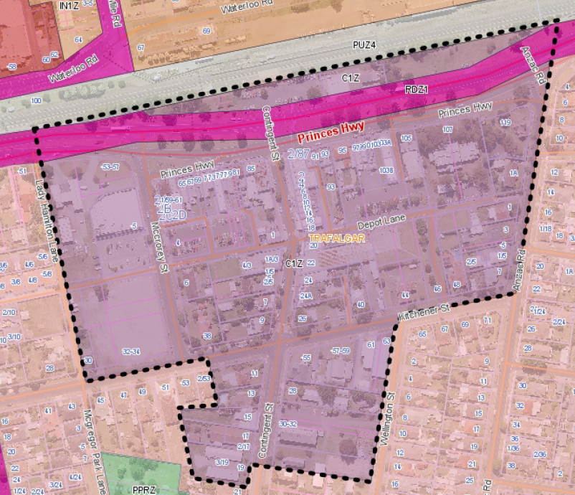

Map 2 – Land affected by the amendment in Neerim South

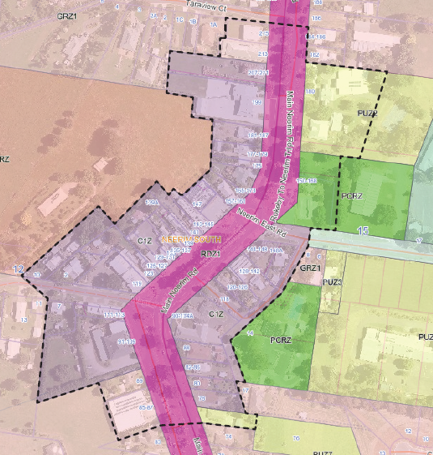

Map 3 – Land affected by the amendment in Longwarry

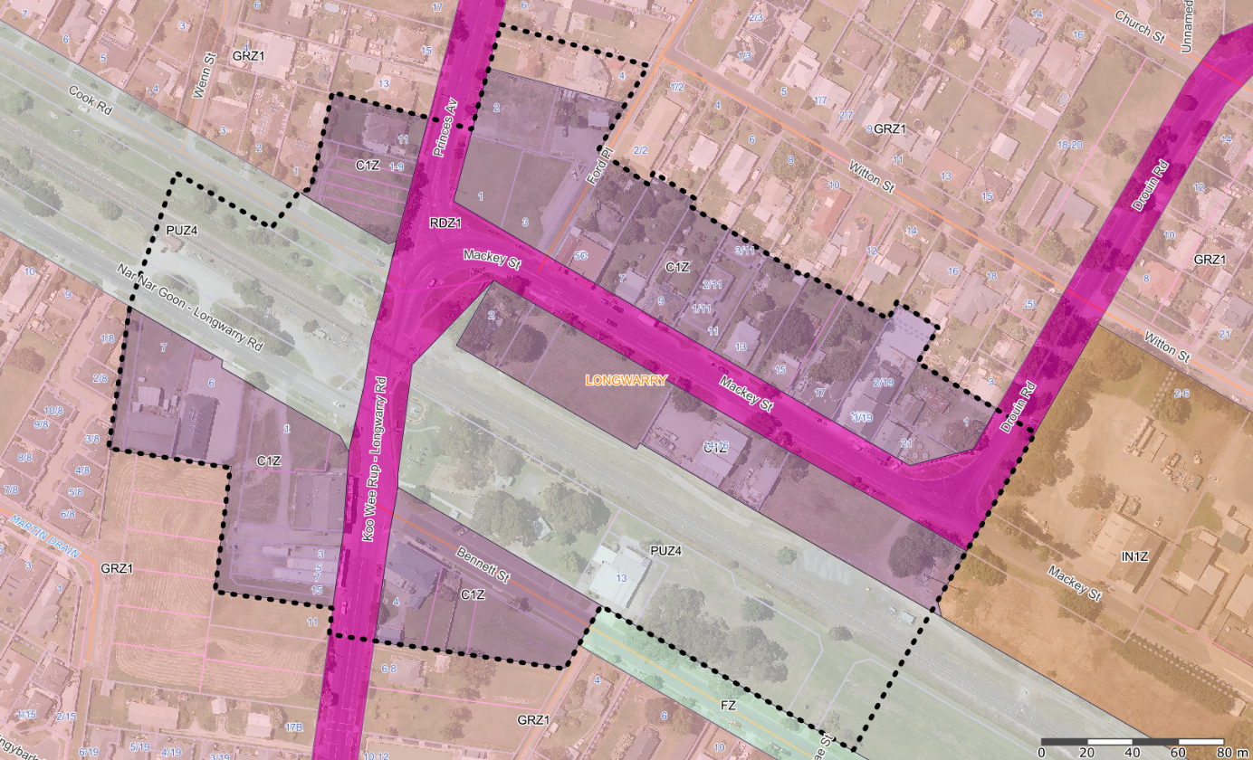

## What the amendment does

The Amendment introduces Design and Development Overlays to implement urban design directions from Longwarry Urban Design Framework 2019, Trafalgar Urban Design Framework 2018 and Neerim South Urban Design Framework 2018.

The Amendment proposes to:

* Apply Schedule 3 to Clause 43.02 – Design and Development Overlay to the Baw Baw Planning Scheme to implement recommendations from the Trafalgar Urban Design Framework and mapping change to 41DDO mapping.
* Apply Schedule 10 to Clause 43.02 – Design and Development Overlay to the Baw Baw Planning Scheme to implement recommendations from the Neerim South Urban Design Framework and mapping change to 14DDO mapping.
* Apply Schedule 11 to Clause 43.02 – Design and Development Overlay to the Baw Baw Planning Scheme to implement recommendations from the Longwarry Urban Design Framework and mapping change to 24DDO mapping.

## Strategic assessment of the Amendment

## Why is the Amendment required?

The amendment is required to achieve the objectives and the strategies of the Urban Design Frameworks by applying the appropriate built form and design controls and giving them statutory effect.

The Urban Design Frameworks set out the strategic direction for Longwarry, Neerim South and Trafalgar which provides a direction for change to guide the built form, use and development outcomes for the town centres for the next 10-15 years.

The Amendment will provide greater certainty about the future built form outcomes for the town centres and the requirements for the consideration of future planning permit applications.

## How does the Amendment implement the objectives of planning in Victoria?

The Amendment gives effect to and is consistent with the following objectives of planning in Victoria identified in section 4(1) of the *Planning and Environment Act 1987*:

* *(1)(a) to provide for the fair, orderly, economic and sustainable use, and development of land.*
* *(c)to secure a pleasant, efficient and safe working, living and recreational environment for all Victorians and visitors to Victoria.*

## How does the Amendment address any environmental, social and economic effects?

The Amendment will have positive economic and social benefits by providing more certainty about built form outcomes that the responsible authority considers to be appropriate within the town centre.

By setting parameters for building heights and setbacks in the centres, the amendment improves the amenity, attractiveness and the economic prosperity of the centres.

The Amendment will have positive environmental effects by improving the interface to open spaces with the intent to encourage increased usability of these spaces with increased passive surveillance and adjacent activation. The Water Sensitive Urban Design will be promoted the these DDOs to minimise negative impacts on the natural water cycle and receiving waterways and bays.

## Does the Amendment address relevant bushfire risk?

There will be no increase of risk with the amendment and the amendment is proposed for existing built-up area.

Therefore, the amendment is unlikely to result in any significant increase to the risk to life, property, community, infrastructure or the natural environment from bushfire.

## Does the Amendment comply with the requirements of any Minister’s Direction applicable to the amendment?

The amendment is consistent with the Ministerial Direction on the Form and Content of Planning Schemes under section 7(5) of the Act.

The amendment complies with the Minister’s Direction No 11 - Strategic Assessment of Amendments. The requirements of Ministerial Direction 15 – The Planning Scheme Amendment Process - have also been considered in the course of preparing this Amendment.

## How does the Amendment support or implement the State Planning Policy Framework and any adopted State policy?

The amendment is consistent with the State Planning Policy Framework of the Planning Scheme with regard to:

* Clause 11.01-1R Settlement – Gippsland: Create vibrant and prosperous town centres that are clearly defined and provide commercial service activities that respond to changing population and market conditions.
* Clause 11.02-2S Structure Planning – Provide for the development of sustainable and liveable urban areas in an integrated manner.
* Clause 15.01-2S Building Design – To achieve building design outcomes that contribute positively to the local context and enhance the public realm.
* Clause 17.02-1S Business – Ensure commercial facilities are aggregated and provide net community benefit in relation to their viability, accessibility and efficient use of infrastructure.
* Clause 18.01-1S Land use and transport planning – To create a safe and sustainable transport system by integrating land use and transport.
* Clause 18.02-1S Sustainable personal transport – Provide direct and connected pedestrian and bicycle infrastructure to and between key destinations including activity centres, public transport interchanges, employment areas, urban renewal precincts and major attractions.

## How does the Amendment support or implement the Local Planning Policy Framework, and specifically the Municipal Strategic Statement?

The amendment is consistent with the following Municipal Strategic Statement and Local Planning Policy Framework of the Planning Scheme:

* Clause 21.03 – ‘Settlement’ by building a close-knit community which appreciates the unique country town character of the settlements in the Shire.
* Encourage housing design solutions that provide a diversity of dwelling types that is responsive to emerging demographic trends and associated lifestyle needs.
* Retain high visual quality of rural landscapes, including preservation of view corridors and vantage points within the urban area.
* Clause 21.07 – ‘Economic Activity’ by seeking to attract high-quality tourist development that is compatible with the environmental values of the area.
* Develop and promote tourism based on natural and built resources. Building design and location should take into account the attributes of the natural environment and local character.
* Clause 21.08 – ‘Transport and Infrastructure’ by developing an appropriate multi-modal transport network that works effectively, with positive outcomes for amenity, safety and environmental values.
* Provide for safe and direct access for pedestrians and cyclists in the design of residential subdivisions in order to reduce the need for use of motor vehicles and to assist in improving community health and wellbeing.

## Does the Amendment make proper use of the Victoria Planning Provisions?

The Amendment makes proper use of the Victorian Planning Provisions (VPP) by implementing the built form and design outcomes of Council adopted Urban Design Frameworks. The use of the Design and Development Overlay is the most appropriate statutory tool to achieve the design outcomes for the towns, as detailed in the three Urban Design Framework Plans for the locations. The overall objective of a Design and Development overlay is *to identify areas which are affected by specific requirements relating to the design and built form of new development.*

The amendment makes proper use of these provisions and has been prepared with consideration of Planning Practice Notes 13: Incorporated and background documents and 17: Urban Design Frameworks.

## How does the Amendment address the views of any relevant agency?

The Urban Design Frameworks undertook extensive consultation with community and external agencies, including VicTrack, VicRoads, Country Fire Authority (CFA).

Further views of relevant agencies will be considered during the exhibition stage of this Planning Scheme Amendment.

## Does the Amendment address relevant requirements of the Transport Integration Act 2010?

The Council, as an interface body under the provisions of the *Transport Integration Act 2010*, has an obligation to have regard to specific matters under that *Act*. In this case, it is considered that the amendment will have no significant impact on the transport system and will not be inconsistent with the transport system objectives and design making principles of the *Act.*

## Resource and administrative costs

### What impact will the new planning provisions have on the resource and administrative costs of the responsible authority?

The amendment is expected to have only a minor impact on resource and administrative cost once it becomes part of the Baw Baw Planning Scheme, as most of the properties affected by the amendment will require a permit for buildings and works under their planning zones. The new controls will provide greater guidance for Council in exercising its discretion under the Baw Baw Planning Scheme.

## Where you may inspect this Amendment

The Amendment is available for public inspection, free of charge, during office hours at the following places:

Drouin Civic Centre

33 Young Street, Drouin (access via Brynwood Avenue)

Office hours: 8.30am to 5.00pm, Monday to Friday

Warragul Civic Centre

Annex Building, 90 Smith Street, Warragul (access via Smith Street)

Office hours: 8.30am to 5.00pm, Monday to Friday

The Amendment can also be inspected free of charge at the Department of Environment, Land, Water and Planning website at [www.delwp.vic.gov.au/public-inspection.](http://www.dtpli.vic.gov.au/planning/planning-schemes/changing-the-planning-scheme/planning-documents-on-exhibition)

## Submissions

Any person who may be affected by the Amendment may make a submission to the planning authority. Submissions about the Amendment must be received by **5pm Tuesday, 7 April 2020.**

A submission must be sent to:

Electronic submissions are preferred and sent to [bawbaw@bawbawshire.vic.gov.au](mailto:bawbaw@bawbawshire.vic.gov.au) (Please mention ‘Amendment C131bawb’ in the subject line).

Or posted to:

Baw Baw Shire Council, Amendment C131bawb

PO Box 304,

Warragul, Victoria, 3820.

## Panel hearing dates

In accordance with clause 4(2) of Ministerial Direction No.15 the following panel hearing dates have been set for this amendment:

* directions hearing: to be held in the week commencing 25 May 2020;
* panel hearing: to be held in the week commencing 8 June 2020.